Color (Diffuse) Texture

📘 Definition
# Source: AI Source: Provided by: [Data Path: Persons Table -> ID Column: 1, Name_En Column: Motasem Essam] -> From: [ChatGPT] on [5/2/2026]
A Color (Diffuse) Texture is a texture that defines the main visible color and surface detail of a 3D object, without showing shine, reflection, or lighting effects.
It is the base image wrapped onto a model to give it realistic appearance.

🧱 How diffuse texture works
# Source: AI Source: Provided by: [Data Path: Persons Table -> ID Column: 1, Name_En Column: Motasem Essam] -> From: [ChatGPT] on [5/2/2026]
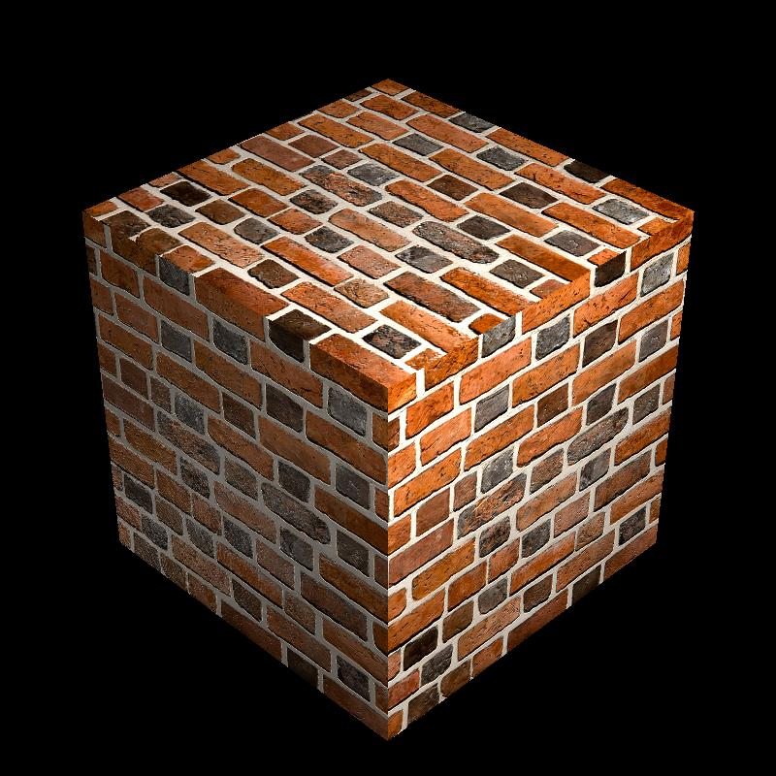
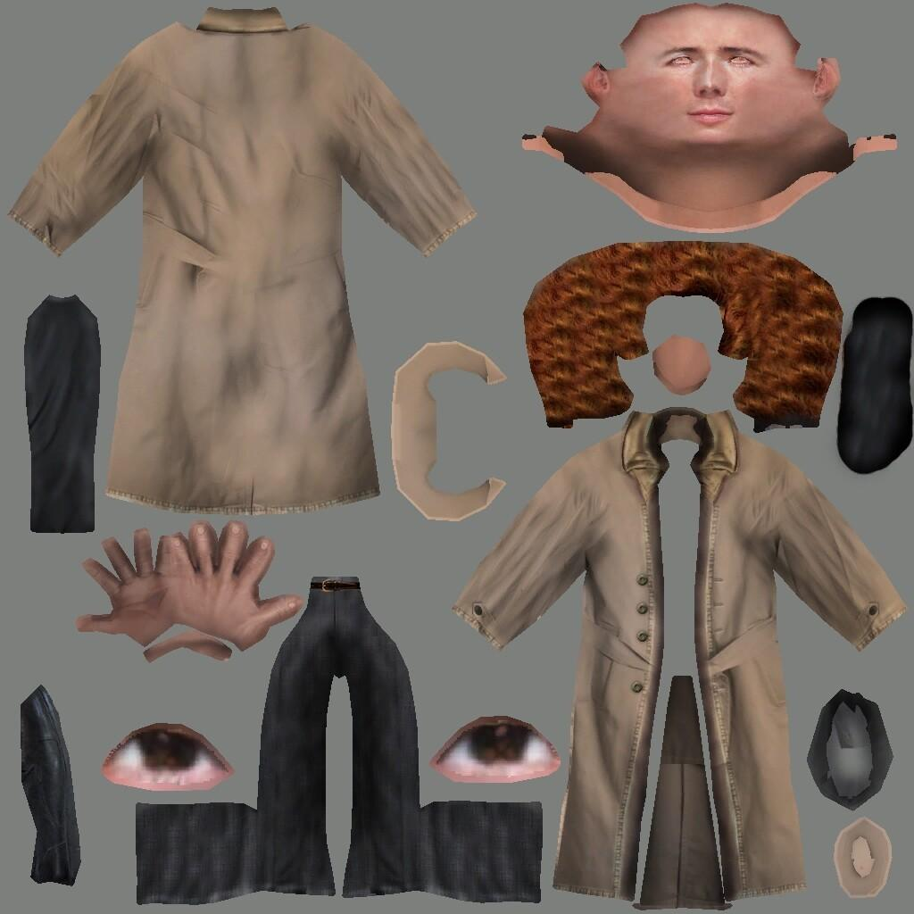
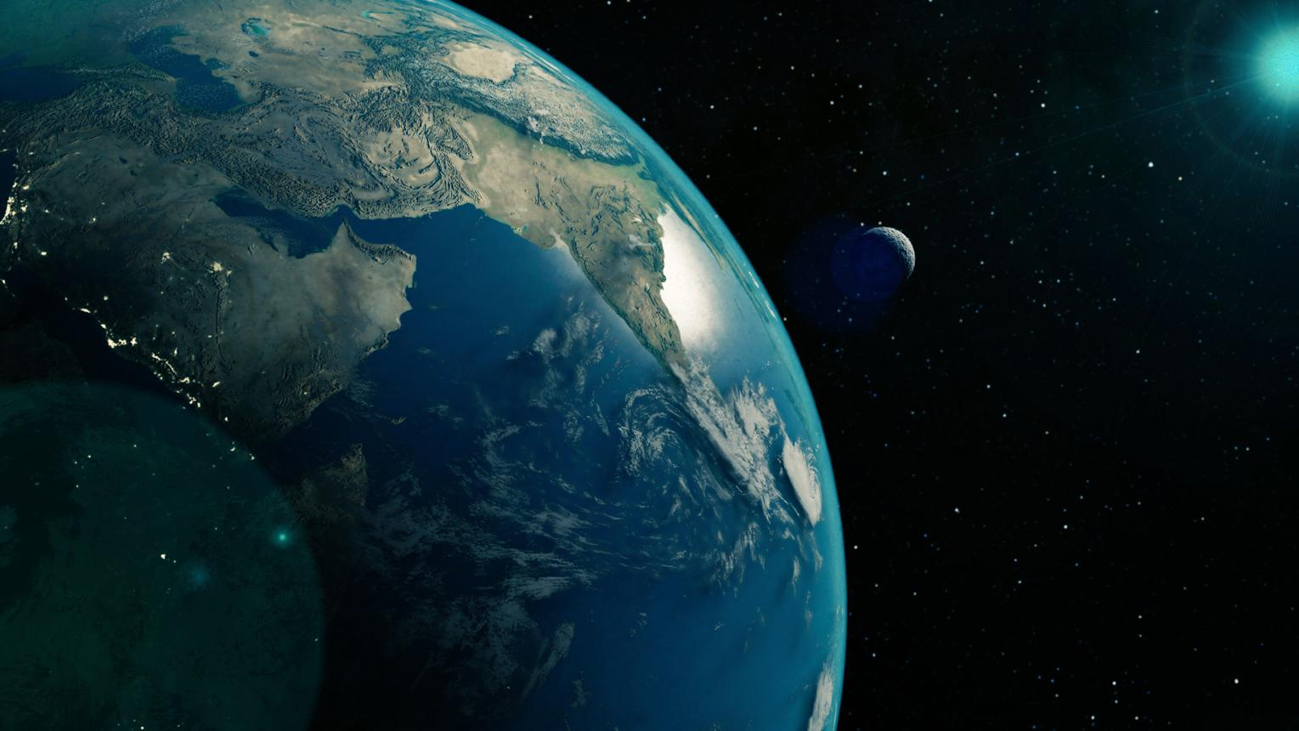
- A 2D image (texture map) is created
- It is wrapped onto a 3D model (UV mapping)
- The object gets its real-world colors and patterns
- Lighting is applied separately on top of it

🧠 Simple example
# Source: AI Source: Provided by: [Data Path: Persons Table -> ID Column: 1, Name_En Column: Motasem Essam] -> From: [ChatGPT] on [5/2/2026]
Think of:
- 🧱 A plain cube → no detail
- 🧱 Same cube with a brick image applied → looks like a real wall
- 🌍 A sphere with Earth image → looks like the planet Earth

🎮 Where diffuse textures are used
# Source: AI Source: Provided by: [Data Path: Persons Table -> ID Column: 1, Name_En Column: Motasem Essam] -> From: [ChatGPT] on [5/2/2026]
- 🎮 Video game environments (walls, floors, characters)
- 🎬 Movies and CGI objects
- 🧑‍🎨 3D modeling and animation
- 🏗️ Architectural visualization

⚙️ Key features
# Source: AI Source: Provided by: [Data Path: Persons Table -> ID Column: 1, Name_En Column: Motasem Essam] -> From: [ChatGPT] on [5/2/2026]
- 🎨 Shows basic color and surface patterns
- 🚫 Does NOT include lighting or shine
- 🧩 Works as the foundation of object appearance
- 🖼️ Usually a flat 2D image

🚀 In short:
# Source: AI Source: Provided by: [Data Path: Persons Table -> ID Column: 1, Name_En Column: Motasem Essam] -> From: [ChatGPT] on [5/2/2026]
Color (Diffuse) Texture = the basic image applied to a 3D object that gives it its real-world color and surface look without lighting effects.

